ISIE Board Meeting June 10th, 2021

Minutes
Meeting called by |  |  | Stefanie Hellweg (SH),
Note taker |  |  | Tim Baynes (TB)
Regrets |  |  | Weslynne Ashton (WA), Ester van der Voet (EvdV), Kazuyo Matsubae (KM),
Attendees |  |  | Heinz Schandl (HS), Alissa Kendall (AK), Callie Babbitt (CB), Shoshanna Saxe (SS), Jooyoung Park (JP), Paul Hoekman (PH), Valerie Thomas (VT), Nina Kisbey-Green (NKG), Ming Xu (MX), Gang Liu (GL) , Reid Lifset (RL)

Agenda topics
0 |  | Welcome |  |  |  | SH
The minutes from previous Board meeting February 24th, 2021 were accepted: proposed by TB, Seconded by RL
1. |  | president’s report and executive director’s report |  |  |  | SH, ph
report | See also President’s & Executive Director’s Quarterly report attached to these minutes
President

SH made particular mention, from the Quarterly Report, of the ‘Grand Challenges’ and cross cutting themes that summarize the strategic outlook of her presidency and are also the subject of an open forum https://is4ie.org/forum/general/43

Executive Director

PH made the following notes in addition to the Quarterly Report
- Website upgrade moving from the aesthetic, to the functional
- IE Day has subsite within the website
- Additional membership in last few months

Conclusions | N/A
Action items |  |  |  |  | Person responsible |  | Deadline
2. |  | Finances |  |  |  | VT
report/Discussion | See Treasurer’s report attached to these minutes

This Board meeting followed closely from the timing of the AGM. A separate quarterly Treasurers report was not needed. See budget and reporting in the Annual Report and the recap at the end of these minutes.

Review of the Budget had no objections – see Financial Committee report notes attached at the end of these minutes
- Have met with Financial Committee June 7th and shown them where are the details that they couldn’t see initially
- No change to the budget published in Annual Report due to anything from the Financial Committee

RL update on money coming from Yale: Bureaucracy is the main impediment

Conclusions | The Society still has to complete the transfer of funds from Yale
Action items |  |  |  |  | Person responsible |  | Deadline
Persist with the process of funds transfer from Yale to Transferwise Account |  |  |  |  | VT, PH, RL |  | ongoing
3. |  | diversity and conclusion |  |  |  | CB
report | See also Diversity and Inclusion (D&I) Statements attached to the end of these minutes
CB reporting on behalf of the Students and seeking a discussion on the following questions:

- What is the vision? - formalizing ISIE commitment
- What will be the structure of initiative going forward?
- How to maintain ongoing commitment to Diversity and Inclusion?

Subsequent to some Board edits (Alissa Kendall suggested removing first 3 words:”ISIE believes that …” from the original supplied in Agenda), there was a decision on the approval of the Diversity and Inclusion Vision Statement by the Board, on behalf of the Society.

TB proposes approval of D&I Vision Statement as written in Agenda with edits, CB seconded.

RESULT: Passed by majority, none opposed.

Students and Callie have brainstormed about governance structures – who makes decisions, who puts forward ideas.

RL: If this is student activity alone, how to attribute / separate responsibility?

CB: D&I could work like Sections – Students would own and be responsible for D&I initiatives and activity

GL supports the overlapping structure – some common D&I areas but also some separate. RL also notes that Students can join without being an ISIE member.

Conclusions | Diversity and Inclusion Vision Statements adopted by the ISIE Board
Action items |  |  |  |  | Person responsible |  | Deadline
Report back to the students on ideas about D&I governance and structure |  |  |  |  | CB |  | Next Board meeting
4. |  | Circular economy (CE) tagline |  |  |  | SH, ph
report | See also previous attachments to Board Meeting minutes of 25th Feb 2021
PH
There was an out-of-session discussion with the Board seeking suggestions/recommendations for CE taglines, but not so many responses. Talked to CE in IE proponents and set up forum. More taglines suggested in forum

What next?
Ask Membership what do they think about range of options

- No tagline
- Science for a Circular Economy
- The Sustainability Science that Informs Circular Economy and Climate Change Initiatives
- Science for Sustainability and Circular Economy

People are referred to the forum

SS one of the reasons for doing this was getting attention in search terms on internet?
Are we looking into this separately. Tagline is controversial and will remain so, but we could easily edit the website tagline in future?

PH this was something not yet discussed - will follow up.

HS isn’t this really better resolved by starting a new CE section?

PH – this is proceeding as they planned in their original Member Proposal

Please note these relevant links:

https://is4ie.org/forum/general/42
https://www.is4ce.org/en/

Conclusions | Forum to garner member feedback on the CE tagline options and subsequent to this an online vote is planned
Action items |  |  |  |  | Person responsible |  | Deadline
Continue discussion in forum and put a vote to the general membership |  |  |  |  | PH |  | Next Board Meeting
5. |  | conflict of Interest |  |  |  | TB/SH/PH
report/Discussion | Preceding the Board Meeting a document on conflict of interest was circulated – see attachments
TB has worked on practical questions to help Board members think about and disclose conflict of interest

SH asks for opinions on the form - general approval, some have already filled it out and returned e.g. MX

SH what is the process for deciding on COI?

TB If the issue is clear enough, it is the role of the Chair to ask people to recuse themselves from a decision at a Board meeting. If there is an open question whether there is COI or not, the Chair asks for a resolution on this question, following a discussion open to all who would be involved in the decision affected by COI.

SH – sometimes people are not aware that they have CoI, hence the purpose of the form

TB – there are many possible ways CoI can manifest, so answers on the form are not the end point

SH – makes a proposal to have a record of the answers to the form.

HS – suggests that we should investigate the privacy issues beforehand

HS/TB – to investigate how does a register of CoI work in other organisation

Conclusions | Conflict of interest
Action items |  |  |  |  | Person responsible |  | Deadline
Write the Conflict of Interest policy into the updated Housekeeping |  |  |  |  | TMB |  | Next Board meeting
Create a Conflict of Interest Register to record responses from the general form and investigate how privacy is managed |  |  |  |  | TMB |  | Next Board meeting
6 |  | reports to the board from proposals, Committees |  |  |  | PH
report | No written reports to the Board
Various reports from Committee members and champions of Proposals

TB/PH report on preparations for IE Day https://is4ie.org/events/event/international-industrial-ecology-day-2021

JP has met with Development Board on interaction with Membership

HS Awards Committee has caught up, formed a panel with deadlines in ~8 weeks. Plans for a Broadcast of Awards in a Lecture – Society Prize lecture

MX Awards Committee – should the committee initiate nominations – still the plan?

HS need to be thoughtful don’t want to create some preferentialism

Development Board – AK nothing to report

ISIE Data Commons – KM not present

Conclusions | - No voting decision required
Action items |  |  |  |  | Person responsible |  | Deadline
Update on the Awards Committee |  |  |  |  | HS MX |  | Next ISIE Board Meeting
Members Satisfaction and Benefits Survey Results online - confirm |  |  |  |  | JP, TB |  | Next Board Meeting
7. |  | journal of Industrial Ecology |  |  |  | RL, PH
report/Discussion | Refer to Google Doc mentioned in minutes below and circulated to the Board
RL presented on the governance and legal arrangements between ISIE and the Journal of Industrial Ecology (JIE).

More material was presented to the Board than is recorded on the website as some of this is subject to a non-disclosure agreement. Please contact the Secretary of ISIE for further information if required

Outsourcing of some editorial office functions
- Main changeover completed
- Working through the trouble shooting

Editors-in-Chief (EiC)
- Search complete and EiCs chosen
- Contracts in preparation
- Budget discussed in this meeting- absent of people with conflict of interest

There are 5 main legal documents/aspects

- Main contract between Yale and Wiley for the publication of JIE (in place)
- Novation – ISIE substituted for Yale throughout the contract (drafted and in review)
- Journal transfer agreement of ownership between Yale to ISIE (drafted and in review)
- Contract specifying the cost of ISIE member access to JIE (in negotiation)
- Editor in Chief contract (being drafted)

The 2nd and 3rd of this list have been sent to Board Members

A decision on the conditions regarding engagement (remuneration etc.) for EiCs was needed and MX, GL recuse themselves on grounds of conflict of interest.

Key provisions in the main contract

- Period 2021-2025
- ISIE owns trade mark, subscription list, publishing rights
- Wiley responsible for copyediting, proofreading, typesetting, formatting & preparation of electronic files, internet subscription, customer service, marketing, promotion, re-prints, sales and management of licenses etc.
- ISIE responsible for aims, scopes, appointing EiC
- EiC responsible for overall process of peer-review, appoints Assoc. Editor and cannot act in a significant editorial capacity on competing journal. Wiley has 1st option on new IE journal started by EiC
- Renewal is automatic unless 12 months notice is given by either party

Other
- Page budget: 2400 page/year (usually JIE published ~half of that)
- Complimentary subscription for Editors, and Editorial Board but would expect these roles to be filled by members of the ISIE anyway.
- Print on demand: 90% discount for members
- Marketing plan – goals actions, estimated marketing expenditure and outcomes, financial reporting
- Limits on freely available articles – “bronze articles” not limited to subscribers
- Non-disclosure agreement applies

Vote to allow SH to negotiate for costs of EiCs: SH proposed, AK seconded, majority in favour, none against

Conclusions | ISIE will receive ownership and management of JIE and we will need a Managing Editor in addition to the 3 new EICs. These costs, and the flat fee to Wiley will need to be balanced by income that includes a fixed payment from Wiley and royalties that are as yet unknown.
Action items |  |  |  |  | Person responsible |  | Deadline
Negotiate annual ongoing costs of EICs with EIC personnel |  |  |  |  | SH |  | Next Board Meeting
Finalize review of JIE Governance Doc by a legal person – report back to JIE Governance Transition Committee |  |  |  |  | PH, VT, SH |  | 4 weeks
8. |  | other business |  |  |  | SH
Discussion
Action items |  |  |  |  | Person responsible |  | Deadline
 |  | meeting closed at 01.00 AM AEDT |  |  |  | SH

ATTACHMENTS FOLLOW

Quarterly summary of activities – President and Executive Director
Mar-May 2021

This document provides an overview of the principal activities and updates from the ISIE over the last three months. It is written up in order to provide an update to the ISIE board in an attempt to shorten reporting-back during the actual board meeting. Prepared by Paul Hoekman and Stefanie Hellweg.

“International Industrial Ecology Day” on June 21, 2021
Preparations for the first Industrial Ecology Day are in full swing. A total of 29 different blocks are currently part of the program, each with a different topic or of a different nature. Four plenary sessions, two poster sessions, and two joint keynotes with ISSST are all part of IE day. It looks to be an intense day packed with interesting sessions and driven by a great number of volunteers. More information on the dedicated sub-site on IE Day.

Membership renewals
Despite not having an in-person meeting, IE Day seems to still trigger a renewed interest in our society. Between March and May we had 136 membership activations. These were 105 new members and 31 reactivations of expired memberships. Our total membership stands at 625 active members, a healthy level.

Transition of the JIE
Some important milestones were reached with regards to the JIE transition, including the selection of suitable candidates for the Editor in Chief position, the preparation of a draft agreement with Yale to transfer ownership and progress with Wiley around the ownership transfer. This topic will be discussed in more detail in the board meeting.

Annual report
After a lot of hard work by a large number of people, the annual report was completed and shared with the membership in April. It is currently released as a "draft annual report", until the membership approves the finances, and it will then be released in its final format.

Annual general meeting (AGM)
Our 2021 AGM took place on May 20th, in digital format. It was attended by 55 members, and the executive team experienced this as a positive event that went smoothly. There was lots of member input from the various sections, committees, and others, and the different items that were opened up to a vote have so far been positively received (voting is still open until June 25).

Membership discussion launched on ISIE strategic direction
On the AGM some initial thoughts were presented about how ISIE could deepen the collaboration between the different method-driven sections and leverage the practical impact of ISIE. The core idea is to create common crosscutting activities (workshops/conference sessions, working groups, sections) about grand environmental challenges. These joint activities on grand challenges can serve as unifying themes to exploit synergies, catalyze collaboration and leverage visibility and ultimately policy impact. So far the following themes were suggested: (1) Reaching the SDGs with IE solutions, (2) Sustainable circular economy, (3) Transition towards sustainable energy systems, (4) Sustainable supply of infrastructure, food, water, and energy for a growing population, (5) Green PostCovid Recovery, and (6) educational material. These ideas have been published on the ISIE Forum to get feedback from the members (see Forum Post “Using synergies within ISIE for solving grand environmental challenges”). So far the feedback on the AGM and the forum has been very positive and constructive. Board members are encouraged to reflect on this and put their views in the forum thread. An in-depth discussion and potentially an implementation strategy is planned to be part of the next board meeting or a separate board strategy workshop.

Circular economy tagline
In the out-of-office vote on the integration of the circular economy tagline, the board neither participated in a large number in the vote nor overwhelmingly approved the integration of "Science for a Circular Economy" on the ISIE website (note: results were Approve: 5, Do not approve: 3, Abstain: 1). In response to this, the executive team liaised with the CE work group and set up a public forum thread, where the general membership, including board members, were invited to comment. This post generated a good discussion and inputs are being used for a membership-wide vote, to be discussed in more detail in this meeting.

Website redesign launched
The ISIE website got a facelift! The new design was launched in April, and while maintaining the general colors and style, it aims to provide for a sleeker layout that is faster to load, works better on the latest devices, and that uses the latest version of the CSS framework (Bootstrap). A number of upgrades were rolled out with the facelift, including full integration of the Membership Spotlight feature, options for scheduling announcements, and most importantly a minisite-feature where conference information can be published and archived. This is now being used by IE Day 2021 to receive abstracts, publish the program, and in general manage the event.
https://is4ie.org/

ISIE Happy Hours
Another update to the website was the introduction of "ISIE Happy Hours". Launched in May, the Happy Hours provide a space for informal, unstructured chats between members. The idea is to try and have these at a regular interval. The first edition took place on May 27th, and it featured 7 different rooms, most of which were set up by our members. The organizers of these sessions reported a positive experience overall, and a wish to continue these events. Two sessions failed to attract participants and increasing the number of attendees will be the focus in the next round - to take place in July after IE Day takes place this June.

Other short updates
Our latest section membership numbers look as follows (previous quarterly report -> figures as per Jun 9)
o Life Cycle Sustainability Assessment: 233 -> 309
o Socio-Economic Metabolism: 226 -> 299
o Sustainable Urban Systems: 190 -> 261
o Students: 159 -> 229
o Industrial Symbiosis and Eco-industrial Development: 159 -> 218
o Environmentally Extended Input Output: 172 -> 225
o Island Industrial Ecology: 50 -> 72
o ISIE total membership: 626 members

Treasurer’s Report, ISIE, June 10, 2021, Valerie Thomas, Treasurer

The ISIE account balance as of June 9th, 2021, is 156,867.75 euros.

For the year 2020, ISIE had a gross profit of 95,226.52 euros. Of this, 72,256.52 euros is transfer of funds from Yale’s ISIE account to ISIE, which happened in June 2020. The rest is memberships. ISIE’s operating expenses were 33,248 euros, primarily remuneration for the Executive Director and the Secretariat and for the Journal of Industrial Ecology. A balance sheet and a profit and loss statement for 2020 are attached.

Recap of 2020 Finances

- Expenses: We have been resilient despite the pandemic, with low operating expenses. Even so, without conference income our expenses exceed our income. We need a long-term solution for our conference-dependent income.

- Remunerations: There are two main paid positions within the ISIE: the Administrative Assistant running the secretariat, and the Executive Director. In 2020, these remunerations were 61% of our expenses. In addition, the Secretary and the Treasurer receive a modest remuneration.

- Office Expenses: We have contracted with Penguin Protocols for website management. And we have expenses for accounting software, communication services (Zoom), and banking fees.

- Travel: No travel took place in 2020, and none is budgeted for 2021. We have tentatively reserved some travel budget going forward.

- Scholarships and Awards: The ISIE usually makes available scholarships for students to attend the biennial conference. A budget is also made available during the alternating years to support the other conferences. There were no expenditures for scholarships or awards in 2020.

- Projects and Initiatives: We expect that member-driven proposals and other projects will become a pillar in our society. We did not have any spending in this category in 2020. We plan to spend €20500 in 2021.

- Journal of Industrial Ecology: We are in the process of transferring the ownership of the Journal of Industrial Ecology from Yale University to ISIE. Expected income from the JIE is shown We expect this year that ownership of the Journal of Industrial Ecology will be transferred from Yale University to the ISIE. The amounts are currently not fully known. The agenda shows income from the JIE, and exactly matching expenditures for the JIE.

Review of the Finance Committee
- Eugene Mohareb and Hiroki Tanikawa, received May 19, 2021. “After reviewing the 2020 financial statement, the Finance Committee has no objections or concerns around the 2020 figures presented.”
- Follow up conversation held June 7, 2021 to clarify details and consider recommendations for clarifying the presentation of the budget for next year.

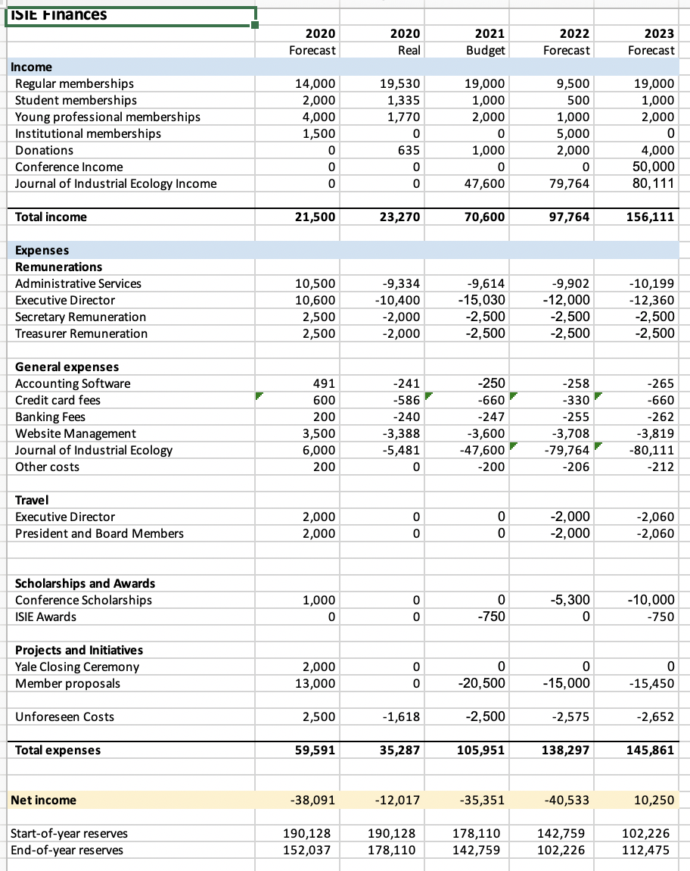

Diversity and Inclusion Vision Statement

Vision Statement

Diversity, equity, and inclusion are at the core of our mission to create innovative solutions to global sustainability challenges and facilitate communication among diverse stakeholders. We are committed to creating an inclusive culture where all people have the opportunity to contribute to, benefit from, and shape the field of Industrial Ecology.

Diversity and Inclusion Goals:

- Increase the voice, representation, and participation of students, researchers and practitioners who reflect the diversity of global society but who have been historically underrepresented in Industrial Ecology.
- Provide opportunities and resources for ISIE members to learn about diversity and inclusion principles.
- Enable broader participation in and accessibility of ISIE conferences and events
- Incorporate diversity and inclusion principles that mitigate implicit bias in publishing, awards, and recognition
- Promote diversity and inclusion in the governance and leadership of ISIE

The Diversity and Inclusion Initiative has also reported activity on …

- Development of a D&I Strategy
- New portfolio of activities for the coming year (2021)
See also https://docs.google.com/document/d/1_SYNqkqg6QEVl1whT-yZepKeTFcuxn4kOwag5O1kmE4/edit

Some practical questions regarding Conflict of Interest

Name of board member: [INSERT NAME HERE]

The purpose of conflict of interest (COI) disclosure is to make you and others involved in ISIE decision making aware of its many forms and to disclose situations that might affect your objectivity.

Conflict of interest is most clear if you are part of a Board decision that results in your direct or indirect personal gain, or where your responsibility to another organization competes with your role(s) and responsibilities at ISIE. There are more subtle indirect forms of COI. It is advisable to take a precautionary approach and disclose anything you think could be COI.

Declaring a conflict of interest may often (but not always) mean that you are excluded from discussion where this COI is relevant, and it will likely mean you cannot be part of the decision making. Declaration is about being transparent about possible biases you might have so that others have a more complete context to your contribution.

Please have a look at the example questions below and consider whether you might be conflicted in financial or other decisions the ISIE Board makes.

Question | Yes/No | Specification of COI and (optionally) where it may be relevant
Are you employed by or contracted to ISIE or considered for hiring (e.g. for the JIE)?
Do you have a relationship with someone employed by or contracted to ISIE, or that ISIE is considering hiring (e.g. family relationship, flat mate, working colleague at same institute, PhD advisor)?
If you feel uncomfortable disclosing names/relationships here, just indicate yes/no as an answer.
Do you have editorial duties at other journals or are you a staff of a journal other than the JIE?
Note that submitting papers or doing reviews for other journals is not considered COI here
Are you a stakeholder in an organization that ISIE has, or plans to have, contracts with?
Are you in a leadership role of another organization that competes directly with ISIE (e.g. for membership or conference attendance)?
Are there any other potential conflicts of interest you might have in your role as Board member at the ISIE that you can think of?

